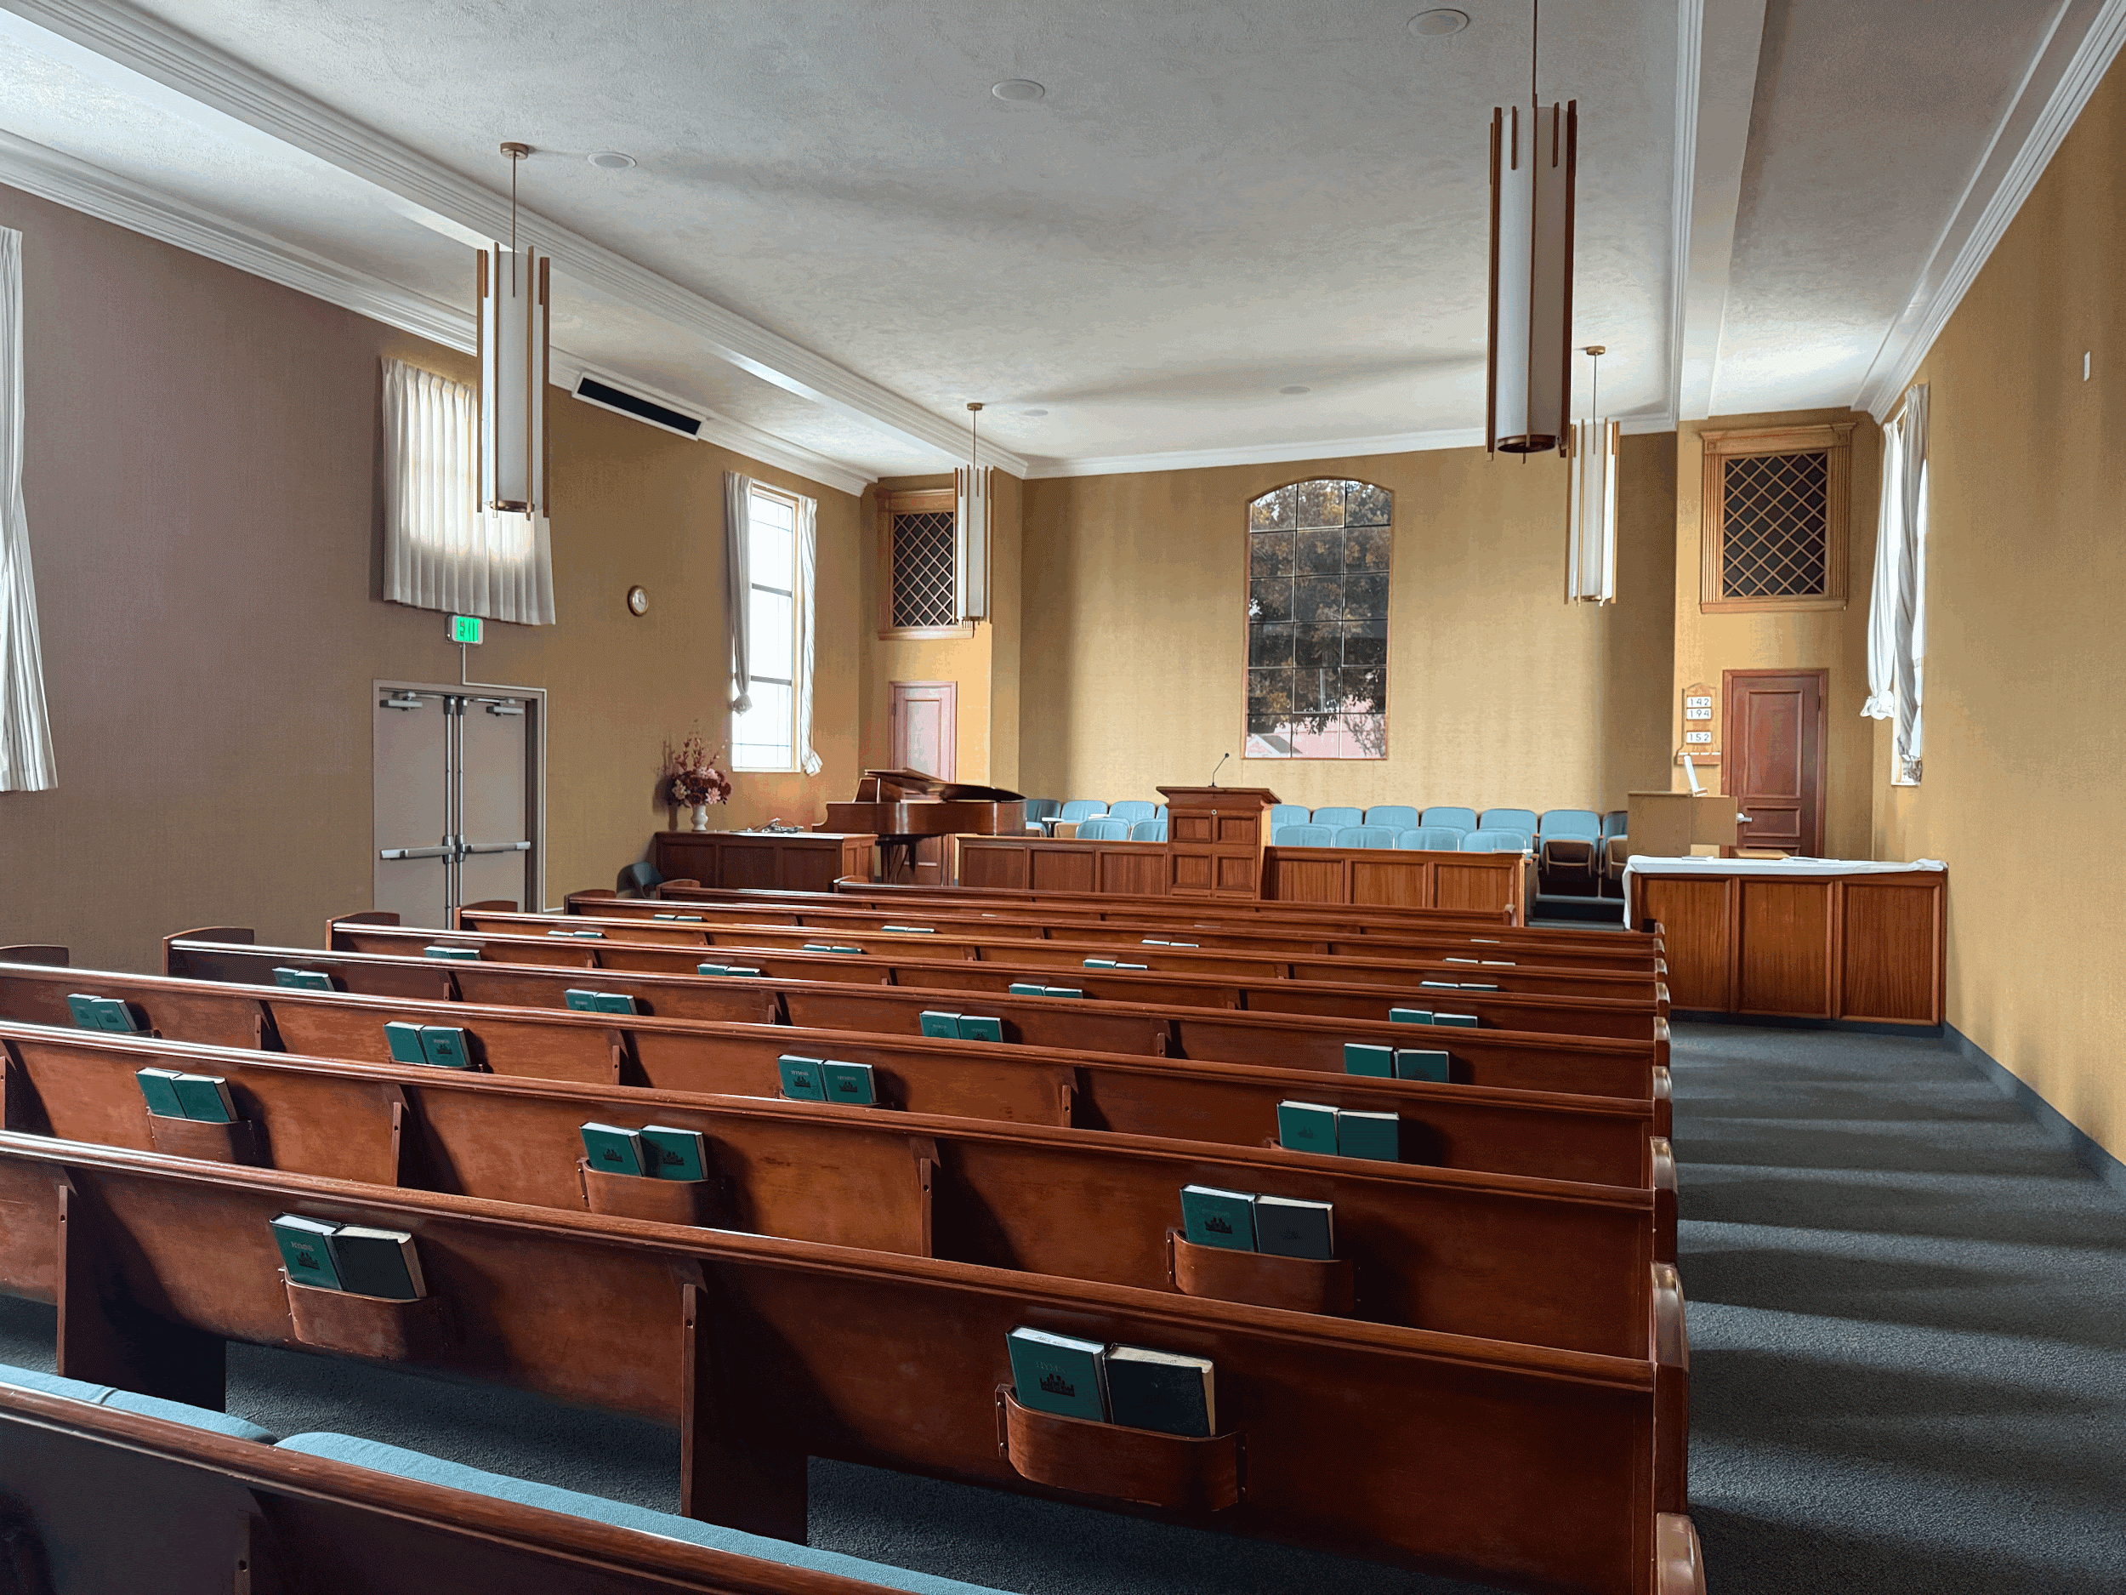

SAN DIEGO

House of Prayer

# Offer Update

#### Dear brothers and sisters,

Thank God that the Mormon Church (LDS) has agreed to San Diego House of Prayer’s offer price of **$3.6M** for the 6840 Osler Street property on 5/19/2025! The original asking price of this property was $4.0M. It is truly God’s guidance and grace that we have even come to this point since four other offers were at much higher price points.

We understand that it is usual practice to provide a signed contract before soliciting contributions, but LDS wants to see proof of funds ASAP, BEFORE they are willing to sign the contract. Time is of the essence since we cannot move forward without proof. We need roughly **$1.3M** after factoring in all contributions, pledges, and loans from various sources so far.

# Request

We sincerely and humbly hope that members can help us with the roughly $1.3M shortfall within the week. It can be in the form of contributions, pledges, and/or loans. Please let us know if you have further questions or can make an immediate loan. Please also forward this request to members who can help.

# Rationale

Since the approval process to go through respective Councils and Congregational Meetings takes time, we hope that individual members can help and churches can expedite the process if possible. We understand that many churches have already graciously supported other churches in the recent months; however, we pray that God who has begun a good work in us will complete it.

We have been searching for a building through the years, but it is only now that we have a concrete option. While the building size is much bigger than our current need, there have been no other suitable options considering the location, price, suitability, and amenities. We also earnestly pray for our church in San Diego to grow with God’s guidance and blessing. Ultimately, our mission is to make disciples of all nations, for which this building is purchased.

# Instructions

| Wiring Instructions: | Zelle Payments: |
| --- | --- |
| Bank name: U.S. Bank  Bank Address: U.S. Bank  800 Nicollet Mall  Minneapolis, MN 55402  Swift: USBKUS44IMT  Routing Number: 122235821  Account Name: True Jesus Church in San Diego  Account number: 155538554694  Account Address: 8081 Mira Mesa Blvd. San Diego, CA 92126  Note: please email us separately at [sd.tjc.fa@gmail.com](mailto:sd.tjc.fa@gmail.com) so that we can send you a receipt | Account name: True Jesus Church in San Diego, California  Email address: [sd.tjc.fa@gmail.com](mailto:sd.tjc.fa@gmail.com)  Include the email address you would like the receipt sent, or email us separately at [sd.tjc.fa@gmail.com](mailto:sd.tjc.fa@gmail.com) |
| Check: |
| Payable to: True Jesus Church in San Diego  Mailing address: 6179 Artisan Way, San diego, CA 92130  Include the following on the check:   1. Name and email (for the receipt) 2. Memo: “Chapel Purchase” |

*If you are willing to make a loan on top of your offering, please contact our council ([san_diego@tjc.org](mailto:san_diego@tjc.org)).

We are grateful for the love and support of our brothers and sisters in Christ. Please reach out to Br. John Liang (Chair) at [liang.john@gmail.com](mailto:liang.john@gmail.com) /(408) 701-1000 / Line ID: johnliang777, or Br. John Chou (Financial Affairs) at [johnchou1993@gmail.com](mailto:johnchou1993@gmail.com) if you have further questions or concerns. May the Lord remember your generosity, love, and prayers.